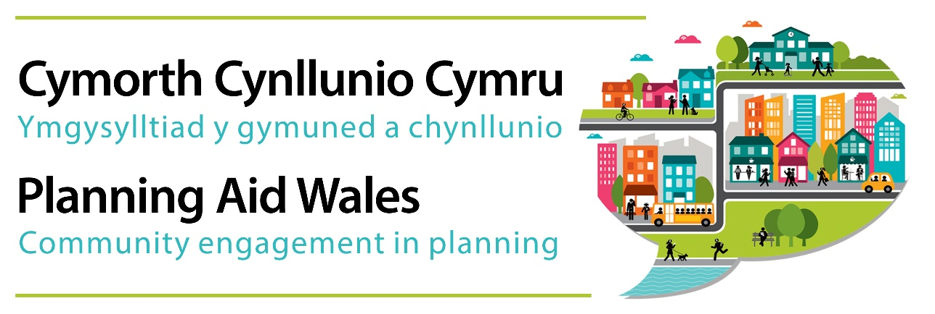

Response to ‘Strengthening Local Government: Delivering for people’ consultation

To: StrengtheningLocalGov@gov.wales

Date: 12th June 2018

1. About Planning Aid Wales

1.1 Planning Aid Wales (PAW) is the charity supporting communities and planning authorities to work better together in shaping places. We are core funded by Welsh Government but retain a high degree of freedom to act independently on behalf of communities.

1.2 Planning aid is about giving people the information and support they need to understand and engage positively with planning. We work to help local communities in Wales to understand and engage more effectively with planning. We do this by explaining the planning process from a community perspective and building capacity for constructive community engagement through our information, advice and training services.

1.3 We also work with the planning profession, planning authorities and Welsh Government to encourage more effective community involvement in the planning process. Through the delivery of planning training courses and workshops, we have worked extensively with Community and Town Councils in Wales to help raise their capacity to engage with planning matters.

1.4 When responding to consultations such as this, our aim is to identify potential barriers which might prevent effective or manageable community involvement in planning.

1.5 We are happy for our response to this consultation to be made public.

2. General comments

2.1 Planning Aid Wales has focused its comments on the general principles on the options for achieving larger Local Authorities and the potential impacts on communities in respect to engagement in land use planning. The effects of the three options outlined, whilst raising different issues in relation to finance and local government management, are likely to raise similar issues with respect to the ability of local communities to understand and engage with planning matters.

2.2 Broadly, the merging of existing Local Authorities is likely to create uncertainty for local communities. Our experience of working with communities within existing local planning authority boundaries is that they already feel distanced from decision making in planning matters. Any of the regional models outlined will likely increase this distance, creating greater uncertainty over who decision makers are and whether local matters and concerns will have any impact on decision making.

2.3 It is likely that pursuing either option 1 or 2 will exacerbate uncertainty whilst arrangements are being negotiated and implemented, even if these options have greater potential for local input into decisions on such arrangements. At the least, pursuit of any of the options should include strong mechanisms to ensure transparency and community participation at every opportunity possible.

2.4 It is noted that there is no reference to the three existing National Park Authorities in Wales in the paper. The particular demands of land use planning and the role of National Park Authorities as well as Strategic Development Plans should be specifically taken into account to provide a sustainable structure across all local services.

2.5 Community and Town Councils are referenced in chapter 7. Whilst recognising that a review of the sector is due to report during 2018, it is essential that any changes to the role of Community and Town Councils is clarified in future proposals, particularly given both their existing and potentially extended role to advocate for local issues in land use planning matters. It should also be noted that there are approximately 130 community areas in Wales that are not represented by a community or town council – appropriate mechanisms for ensuring local representation in planning matters in these areas should be considered.

3. Responses to consultation questions

3.1 Our responses to specific consultation questions are given in italics below:

Consultation Question 1

- What practical steps could the Welsh Government take to make current regional working easier and more effective, for example in relation to education consortia, social services and the City Regions and City and Growth Deals?

No comment.

- What are your views on the common elements to the process of mergers we outline in this section?

Greater regionalisation / enlargement of Local Authorities has the potential to increase the distance of local communities from the centres of decision making. This is likely to exacerbate the uncertainty of who is making the decisions and who needs to be contacted. Ultimately, it may act as a deterrent to involvement and a lack of ownership / acceptance of any decisions that are made.

The respective roles of Local Authority members and Community and Town Councillors is not yet clear in the proposals, in terms of who represents local community interests in planning, and how. Local government reform does provide an opportunity to clarify the nature of and distinction between these two different roles within a new Local Authority arrangement.

Voluntary and phased mergers do appear to identify some positive benefits in relation to Local Authorities having the ability to make decisions on the new arrangements, but such approaches may lead to further confusion on the part of communities. One example would be where a new area is identified comprising 3 current authorities and only two agree a voluntary arrangement, the arrangements for the third area would be unclear. This could lead to planning policy and strategic development being judged on a sub-regional area with implications for communities in the third authority who may not able to fully engage in the process.

- What are your views on the options for creating fewer, larger authorities which we have set out?

The larger authorities as set out would in some cases encompass significant land areas which may encompass significant variations in socio-economic and land use priorities. For example, an authority comprising Carmarthenshire, Pembrokeshire and Ceredigion would cover such a large area that it may require sub-regional development plans (not dissimilar to existing LDPs) in order to ensure the regional variations are adequately considered and to allow the communities in the respective regions to have a say on their area.

A mechanism would also be needed to recognise the regional variations e.g. to ensure an appropriate spread of development and to avoid too great an emphasis on ‘key settlement’ approaches to land use planning. Without an appropriate mechanism to ensure all communities can engage effectively, it is feasible that future planning policy and development may be at risk of being dominated by the larger towns and cities to the detriment of the smaller towns and rural communities within a new Local Authority area.

In relation to planning documents (policy and planning applications) it is important that all information is readily available and easily accessible on websites and there is access to this at the local community level e.g. local library or other community facility. Similarly, there is a need for access to authority officers at a local level. If someone has to travel significant distance to a regional council head office this will likely act as a deterrent to engagement.

Consultation Question 7

- How can councils make more effective use of their elected members knowledge of, and connections in, their communities.

A comprehensive programme of planning training is essential for all elected members to effectively advocate for the communities they represent within the planning process.

The document mentions the importance of town and community councils in providing a voice from the local level. In considering the widespread local government review there may be a need to enhance the powers of the town and community councils in relation to planning matters. For example, some of the larger town and community councils might be willing/able to take on additional planning responsibilities as part of a phased programme, subject to ensuring there is commitment, capability and appropriate resources for to them to do so. There is likely to be a need to provide greater resources to community and town councils in order to meet any increased responsibilities.

Building capacity across the community council sector will enable constructive contributions to plan-making and development management decisions. For example, encouraging and supporting community councils to work with the relevant planning authority to develop Place Plans for their area would help to develop their understanding of planning and their expertise in influencing the planning process to benefit local communities. Place Plans could have greater importance within a larger Local Authority, especially if there is greater emphasis on their status within the development plan framework as adopted SPG. Such an approach would provide a clear local input to the planning process and provide a sense of ownership and consent to new development at a local level.

There is no community and town council representation in 130 community areas in Wales. These areas include the urban centres of Cardiff, Newport and Swansea, Rhos-on-Sea and Old Colwyn in Conwy as well numerous areas along the Heads of the Valleys corridor encompassing Neath Port Talbot, Rhondda Cynon Taf, Merthyr Tydfil, Caerphilly, Blaenau Gwent and Torfaen. Many of these areas are comprised of some of the most deprived areas in Wales. Any new arrangements that strengthen the role of community and town councils as representatives of local issues should consider suitable mechanisms / alternative arrangements for communities within those areas that do not benefit from community and town council representation.

